Check order:
- Visual inspection
Rust
Dust
Corrosion
Components drop
Back plane
Water drops

- 12V input ripple measurement with oscilloscope

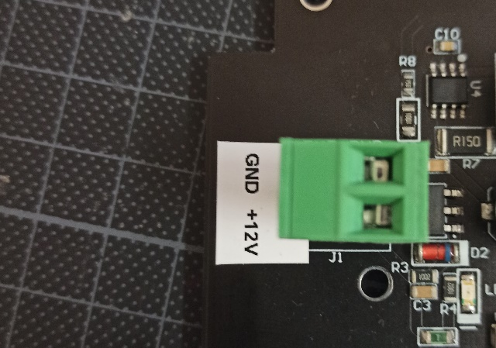

- 3.3V 3.8V and 20V test point measurement

TP4: 20V
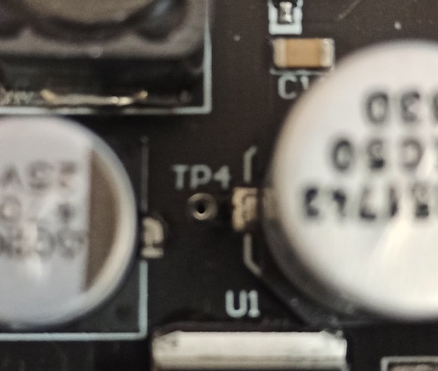

TP1: 5.3V TP2:3.8 TP3:3.3V
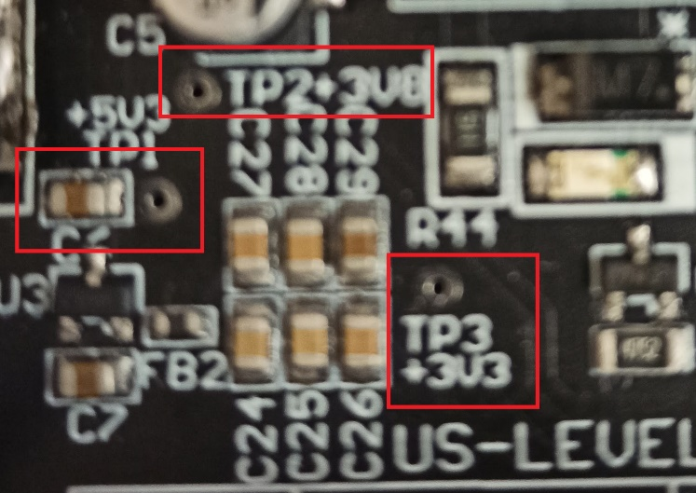

TP5: GND
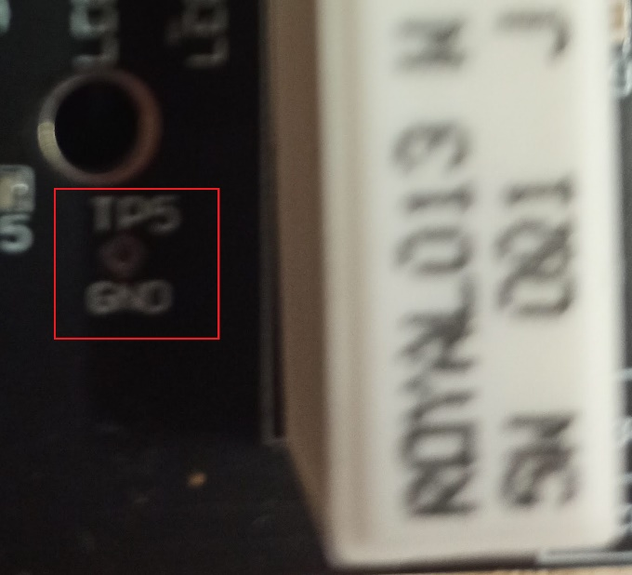

- GOSUNCN external power: this pin should provide 2.7V

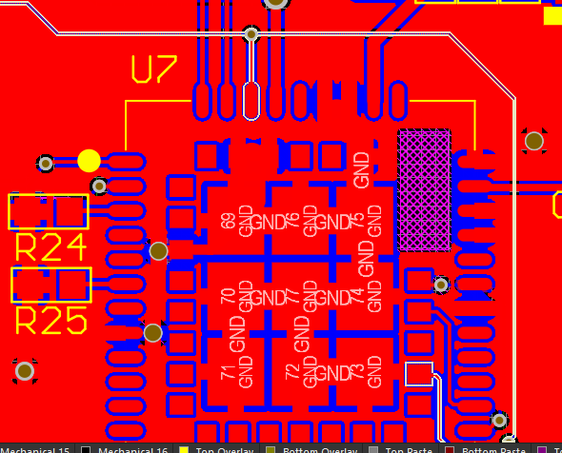

- UART Monitoring



